[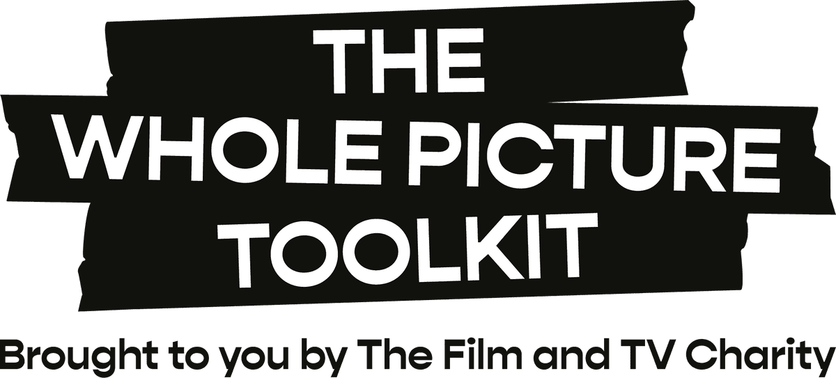](https://wholepicturetoolkit.org.uk/)**Working well with me   
– on a production: template**

For guidance on how to complete this template:

* See our Toolkit guide: [**Communicate your wellbeing plan to your team**](https://wholepicturetoolkit.org.uk/pre-production/communicate-your-wellbeing-plan-to-your-team/).
* Download our [**example Working Well document**](https://wholepicturetoolkit.org.uk/app/uploads/2023/09/Working-Well-With-Me-example.docx) to see typical responses.
* Use the desktop version of Word (rather than browser) for the best editing experience, adjusting spacing as preferred.
* For suggestions to improve this template, or any part of the Toolkit, we’d love to [**hear from you**](https://surveys.hotjar.com/25003442-e9a4-4aef-82b5-c0c7ecf9d920).
* © The Film and TV Charity: Guidance in this editable template should not be altered, and all [**Whole Picture Toolkit**](https://wholepicturetoolkit.org.uk/) references, links and images must be retained. For more details on this, please see our **fair use notice** below.

**Information for crew**  
Our simple questions can support you in building stronger working relationships as, on fast-paced productions, it can be hard to find the time to really get to know each other.

It’s not compulsory to fill this in, but it’s a great way to introduce yourself to your team and start a conversation about how you all can thrive on set.

It’s also your opportunity to highlight your wellbeing needs.

If you’d prefer a discussion, rather than writing things down, let your team leader know.

They’re obliged to keep details confidential, but may need to share some information with HR or other leaders, and should discuss this with you in advance (see ‘protected characteristics’ below).  
  
Let your manager know if you would like them to share any of your details with the wider crew – or, if you’d feel more comfortable sharing yourself.

**Guidance for team leaders**  
Ensure that anyone completing this questionnaire knows which leaders, managers and HR may read the details provided. Privacy policy and GDPR rules should be followed.

Although it’s not always possible to accommodate requests, let your team know that they should flag any needs that aren’t being met during production.

**Protected characteristics**  
To comply with the Equality Act 2010, which legally protects people from discrimination, your team leader may need to share information related to the act’s nine protected characteristics with HR or other managers.

They are:

* Age
* Disability
* Gender reassignment
* Marriage and civil partnership
* Race, including colour, nationality, ethnic or national origin
* Religion or belief
* Sex
* Sexual orientation
* Pregnancy and maternity leave

**[Production name]**

**[Your name and role, and preferred pronoun if you’d like]**

1. **What things do you think help you stay mentally healthy at work?**   
   [Insert your answer]
2. **Are there any details you’d like to share about your current working situation?**[Insert your answer]
3. **Do you have any access needs that would help you to thrive in the workplace? This could be related to physical or mental health.**[Insert your answer]
4. **Is there anything we should be aware of that might help you work at your best, with consideration to the above?**[Insert your answer]
5. **In times of stress, what does helpful support look like to you?**[Insert your answer]
6. **What support can your manager, head of department or colleagues put in place to minimise triggers and/or help you to maintain good mental health?**[Insert your answer]
7. **Are there any early warning signs that your manager, head of department or colleagues might notice when you are experiencing poor mental health?**[Insert your answer]
8. **Do you have any specific training needs?**[Insert your answer]
9. **Do you have any important personal events coming up?**[Insert your answer]
10. **Anything else you’d like your team to know about you? This is your form, so please feel free to add whatever information you’d like to share.**[Insert your answer]

**Copyright and fair use notice**  
© The Film and TV Charity  
  
Guidance in this editable Word template is designed with input from industry, mental health and legal experts, and is reviewed and updated by them and our teams from time to time. The guidance should not be altered.  
  
All [**Whole Picture Toolkit**](https://wholepicturetoolkit.org.uk/) references, links and images must be retained on this template, though we appreciate that production companies may wish to add their own branding as well as the production information that’s relevant to the template’s purpose.    
  
All other Toolkit guidance – that is, non-editable guides – should not be altered in any way.  
  
Templates and guidance can be downloaded and/or printed for distribution.  
  
For more information, see our [**Terms and Conditions**](https://wholepicturetoolkit.org.uk/terms-conditions/).

[](https://wholepicturetoolkit.org.uk/)